LITERATURE SURVEY

|  |  |
| --- | --- |
| Date | 08 October 2022 |
| Team ID | PNT2022TMID03254 |
| Project Name | Intelligent Vehicle Damage Assessment and Cost Estimator for Insurance Companies |
| Maximum Marks | 2 Marks |

**INTRODUCTION:**

In today’s world, accidents are very common because the people are driving cars very fastly on the road. People claim the money for repair through vehicle insurance when the accident happens. The damaged car is examined and it will take more time to claim the amount checking all the company policies. And because of incorrect claims, the company doesn’t make payments properly. So, just by sending the image of damaged car, the website of Intelligent Vehicle Damage Assessment and Cost Estimator for Insurance Companies performs damage detection in a minute rather than days if it is inspected visually.

|  |  |  |  |  |  |  |
| --- | --- | --- | --- | --- | --- | --- |
| S.  NO | PAPER TITLE | AUTHOR(s) | YEAR | ABSTRACT | FUNCTIONS | RESOURCE LINK |
| 1. | Intelligent Vehicle Damage Assessment system based on computer vision | Zhu Qianqian, Guo Weiming, Shen Ying,  and Zhao Zihao | 2020 | At present, under the guidance of the new generation of information technology, the rapid accumulation of data, the continuous improvement of computing power have made profound changes in the development environment  of artificial intelligence. | The system completes the whole process of survey and damage determination through four functions.  They are:   1. Accident investigation, 2. Intelligent image damage assessment, 3. Damage result output, 4. Vehicle insurance anti-fraud. | [(PDF)](https://www.researchgate.net/publication/341569399_Research_on_Intelligent_Vehicle_Damage_Assessment_System_Based_on_Computer_Vision)  [Research on](https://www.researchgate.net/publication/341569399_Research_on_Intelligent_Vehicle_Damage_Assessment_System_Based_on_Computer_Vision) [Intelligent](https://www.researchgate.net/publication/341569399_Research_on_Intelligent_Vehicle_Damage_Assessment_System_Based_on_Computer_Vision) [Vehicle](https://www.researchgate.net/publication/341569399_Research_on_Intelligent_Vehicle_Damage_Assessment_System_Based_on_Computer_Vision) [Damage](https://www.researchgate.net/publication/341569399_Research_on_Intelligent_Vehicle_Damage_Assessment_System_Based_on_Computer_Vision) [Assessment](https://www.researchgate.net/publication/341569399_Research_on_Intelligent_Vehicle_Damage_Assessment_System_Based_on_Computer_Vision) [System](https://www.researchgate.net/publication/341569399_Research_on_Intelligent_Vehicle_Damage_Assessment_System_Based_on_Computer_Vision) [Based on](https://www.researchgate.net/publication/341569399_Research_on_Intelligent_Vehicle_Damage_Assessment_System_Based_on_Computer_Vision) [Computer](https://www.researchgate.net/publication/341569399_Research_on_Intelligent_Vehicle_Damage_Assessment_System_Based_on_Computer_Vision) [Vision](https://www.researchgate.net/publication/341569399_Research_on_Intelligent_Vehicle_Damage_Assessment_System_Based_on_Computer_Vision) [(researchgat](https://www.researchgate.net/publication/341569399_Research_on_Intelligent_Vehicle_Damage_Assessment_System_Based_on_Computer_Vision) [e.net)](https://www.researchgate.net/publication/341569399_Research_on_Intelligent_Vehicle_Damage_Assessment_System_Based_on_Computer_Vision) |

|  |  |  |  |  |  |  |
| --- | --- | --- | --- | --- | --- | --- |
| 2. | Car Damage Assessment for Insurance Companies | Mandara G and Prashant Ankalkoti | 2022 | Analysis of the damaged vehicle that can be automatically claiming insurance that takes human resource, time and effort.  Image processing andmachine learning techniques are analyzing the vehicle damage in the proposed solution. In Advanced solution helps to speed up the  claiming process sufficiently. | Detect the car damage using photo taken at the accident scene is very useful to reduce the cost of processing insurance claims, as wellas provide greater convenience for vehicle users.  Dataset Explanation, Describing the level of damage,  CNN Model and VGG16  Algorithm. | [Paper](https://ijarsct.co.in/Paper5048.pdf) [5048.p](https://ijarsct.co.in/Paper5048.pdf)  [df](https://ijarsct.co.in/Paper5048.pdf) [(ijarsct](https://ijarsct.co.in/Paper5048.pdf)  [.co.in)](https://ijarsct.co.in/Paper5048.pdf) |

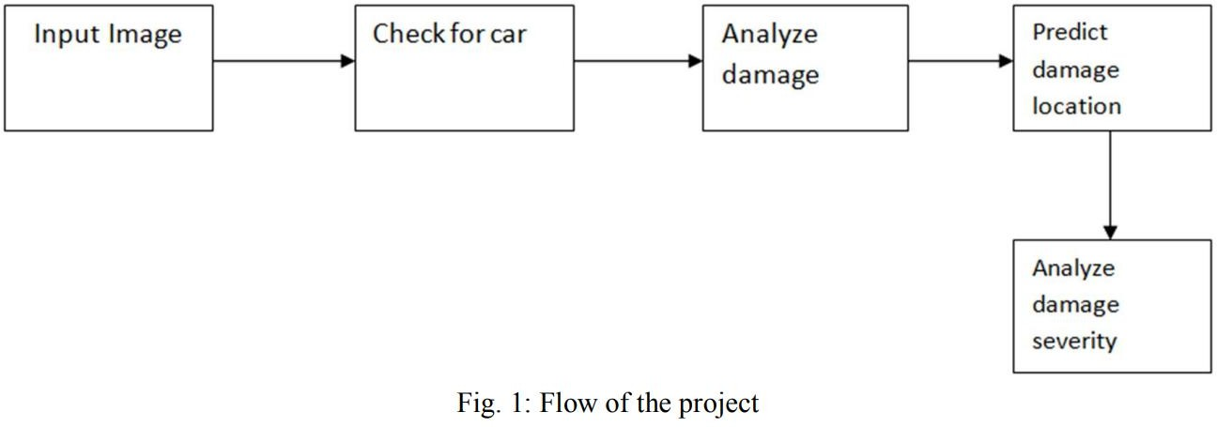

|  |  |  |  |  |  |  |
| --- | --- | --- | --- | --- | --- | --- |
| 3. | Image Based Automatic Vehicle Damage Detection | Srimal Jayawardena | 2013 | Automatically detecting vehicle damage using photographs taken at the accident scene is very useful as it can greatly reduce the cost of processing insurance claims, as well as provide greater convenience for vehicle users. | To use the3D CAD model projection to help in segmenting and separating components of a vehicle body like the doors and fenders which are separated by weak boundary cues. | [(PDF)](https://www.researchgate.net/publication/263619076_Image_Based_Automatic_Vehicle_Damage_Detection)  [Image](https://www.researchgate.net/publication/263619076_Image_Based_Automatic_Vehicle_Damage_Detection) [Based](https://www.researchgate.net/publication/263619076_Image_Based_Automatic_Vehicle_Damage_Detection) [Automatic](https://www.researchgate.net/publication/263619076_Image_Based_Automatic_Vehicle_Damage_Detection) [Vehicle](https://www.researchgate.net/publication/263619076_Image_Based_Automatic_Vehicle_Damage_Detection) [Damage](https://www.researchgate.net/publication/263619076_Image_Based_Automatic_Vehicle_Damage_Detection) [Detection](https://www.researchgate.net/publication/263619076_Image_Based_Automatic_Vehicle_Damage_Detection) [(researchg](https://www.researchgate.net/publication/263619076_Image_Based_Automatic_Vehicle_Damage_Detection) [ate.net)](https://www.researchgate.net/publication/263619076_Image_Based_Automatic_Vehicle_Damage_Detection) |
| 4. | A Very Deep Transfer Learning Model for Vehicle Damage Detection and Localization | Najmeddine Dhieb,  Hakim Ghazzai, Hichem Besbes, and Yehia Massoud | 2019 | Claims leakageis a major problem engendering tremendous losses for insurance companies.  Those losses are due to the difference between the amount paid by insurance companies and the exact amount that should be spent, which cost millions of dollars  yearly. | Deep learning, CNN, and transfer learning techniques are used. | [(PDF) A Very](https://www.researchgate.net/publication/339763247_A_Very_Deep_Transfer_Learning_Model_for_Vehicle_Damage_Detection_and_Localization) [Deep Transfer](https://www.researchgate.net/publication/339763247_A_Very_Deep_Transfer_Learning_Model_for_Vehicle_Damage_Detection_and_Localization) [Learning Model](https://www.researchgate.net/publication/339763247_A_Very_Deep_Transfer_Learning_Model_for_Vehicle_Damage_Detection_and_Localization) [for Vehicle](https://www.researchgate.net/publication/339763247_A_Very_Deep_Transfer_Learning_Model_for_Vehicle_Damage_Detection_and_Localization) [Damage](https://www.researchgate.net/publication/339763247_A_Very_Deep_Transfer_Learning_Model_for_Vehicle_Damage_Detection_and_Localization) [Detection and](https://www.researchgate.net/publication/339763247_A_Very_Deep_Transfer_Learning_Model_for_Vehicle_Damage_Detection_and_Localization) [Localization](https://www.researchgate.net/publication/339763247_A_Very_Deep_Transfer_Learning_Model_for_Vehicle_Damage_Detection_and_Localization) [(researchgate.n](https://www.researchgate.net/publication/339763247_A_Very_Deep_Transfer_Learning_Model_for_Vehicle_Damage_Detection_and_Localization) [et)](https://www.researchgate.net/publication/339763247_A_Very_Deep_Transfer_Learning_Model_for_Vehicle_Damage_Detection_and_Localization) |